**Name: _________________________________**



**Task 8:**

SOURCE ANALYSIS, FORTNIGHTLY TASK FOUR  **Weighting 2% (9 Marks)**

**Question 1**

1. Explain the message of **Source 1**.

***(3 marks)***

2. Identify how and discuss why **Sources 1** and **2** are contestable.

***(6 marks)***

**Source 1:**

[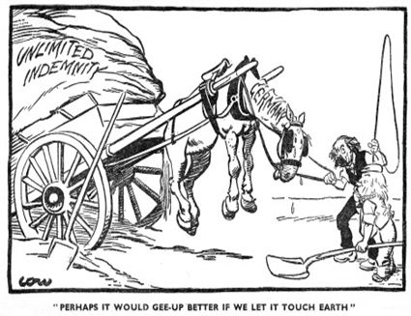](https://www.google.com.au/url?sa=i&rct=j&q=&esrc=s&source=images&cd=&cad=rja&uact=8&ved=0ahUKEwiJiauj8ZnVAhXCsVQKHX4PBoEQjRwIBw&url=https://ashweetha.wordpress.com/2012/05/07/treaty-of-versailles-cartoon-analysis-3/&psig=AFQjCNEUfyxs7s3yBJ76GUdSY0YwWKakHw&ust=1500709656958468)

The source above is a cartoon which was published in the British newspaper “The Star” in January 1921. The cartoon was created by David Low a British artist.

**Source 2:**

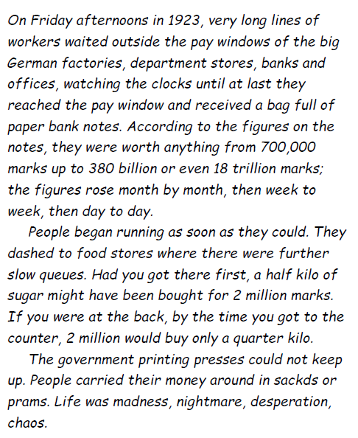

*The source above is an extract from K. Heiden, Der Fuhrer: Hitler’s Rise to Power, 1944.*

*Heiden was a German democrat who lived through Weimar and Nazi Germany; he carefully collected evidence to use in his anti-Nazi writings.*